Course: Biology 12 – Semester 1 (2011) Name: _____________________
School: North Delta Secondary
School Number: 604-596-7471 Date: _____________________
Teacher: Ms. K. Sidhu
Room Number: 2311
Textbook: “Inquiry Into Life” (Eleventh Edition)

Course Website: _____________________________________________
Welcome to Biology 12!
Prepare yourself to learn more about yourself than you ever have before. From the basic building blocks of life, to the beauty of our body systems, Biology 12 explores the mechanics of our own bodies. Why do we create saliva? What happens inside our stomachs? Why can gas be smelled at the back of the room when it came from the front? Why do people take Creatine supplements? Why is it so important to take good care of your heart, lungs, and liver? Through class lectures, group activities, dissections, and projects, we will explore these questions and many more.
Course Outline:
- CELL BIOLOGY  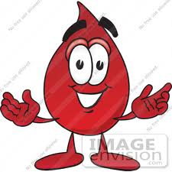  - Cell Structure Chapter 3  - Cell Compounds Chapter 2  - Biological Molecules Chapter 2  - DNA Chapter 24 & 25 | - HUMAN BIOLOGY  - Digestive System Chapter 11  - Circulatory System Chapter 12, 13, 21  - Respiratory System Chapter 14  - Nervous System Chapter 16  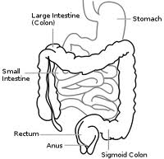  - Reproductive System Chapter 20  - Urinary System Chapter 15
- CELL PROCESSES AND APPLICATIONS  - Protein Synthesis Chapter 24  - Cellular Transport Chapter 4  - Enzymes Chapter 5 | - Fetal Pig Dissection Course Overview
Materials:
Paper, Pens, Pencils, Binder | Scientific Calculator (No Graphing Calculators)
Pencil Crayons and Project Supplies | 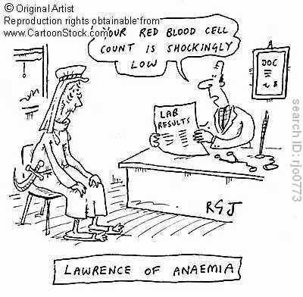  Appropriate Clothing and Shoes for Labs
Field Trips:
Field Trip plans and fees will be discussed in the future once dates are determined.
Evaluation:
Homework: 5% Tests and Quizzes: 50%
Labs/Projects/Assignments: 15% Final Exam: 30%
The above may change based upon teacher discretion.
Classroom Policies:
1. Never speak while the teacher is speaking.
2. Always raise your hand to speak or to leave your seat, and wait for a response before speaking.
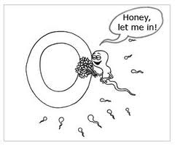
3. Respect your fellow classmates, the teacher, and the classroom. The class is a whole unit, and individuals negatively impacting the class will be dealt with appropriately.
4. No eating, sleeping or personal grooming is permitted in class.
Lates: Students will be kept in after class. The dice will decide for how long.
Washroom Breaks: Two washroom breaks are allowed per student per week.
This may change based on teacher discretion.
Absences:
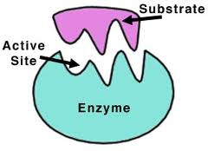
Students are expected to collect all missed work (notes, assignments, etc.) on their own. Absences must be excused by a parent calling the school; notes will not suffice. Absences on the day of a test will only be excused for medical reasons and your parent/guardian will need to call me directly.
  - School Number: 604-596-7471 Extension: _________

Make-up work:
Students have 1 day to make up the work for each day absent, not including the day of return, unless the principal approves an extension due to unusual circumstances. Previously assigned work is due on the day the student returns to school.
Projects and Labs:
Please work cooperatively with your group members and classmates. Participate and do your share of the work. During labs, show respect for living things and specimens. Pertain to science lab safety rules at all times! Unsafe and horseplay will result in the student no longer participating in the present and future activities.
Test and quiz make-ups:
Test and quiz make-ups will only occur if the students has been excused for their absence. Students will take announced tests on first day of return to school. Student will be allowed 2-days to prepare for tests assigned during the absence.
- Most labs cannot be recreated so alternate assignments with similar or same objectives
will be given for make-up work.
Academic Honesty Plan:
Cheating and copying of another person’s work will result in disciplinary action, and any
credit for the assignment, test, or quiz will be taken away.
Tips for Success:
Be responsible for your own work and education. Not everything we do will always be hands-on
or interesting, but everyone needs to achieve the patience and study skills to work productively in such situations. If you do not understand something, do something about it. Avoiding things will just make them into bigger problems, and you will eventually need to find a solution.
- Pay attention during lessons and keep neat notes. | - Use the curriculum guide or PLO’s to keep track of what you have learned.
- Study with others and test yourself independently. Ask yourself “what type of question could the teacher ask you?” | - Study the information gradually: do NOT rely on cramming. You will probably miss out on crucial thinking questions.
- Keep an ORGANIZED notebook | - Understanding the list of key terms for each unit is essential.
- Do the worksheets by yourself, do not wait for answers. Do not copy other people, because you will learn nothing from this. | - Break down each unit into themes/key concepts to prepare for unit tests.
- Read the text chapters and sections that correspond to that day’s lesson. Familiarize yourself with the terminology and diagrams in your text. | - Do your homework and use extra resources to further your understanding.

Please sign and have a parent sign below to acknowledge that you are aware of and accept the course outline, evaluation guide and expectations.
Student Name (print clearly) | Parent Signature
Student Signature | Study Buddy Name

