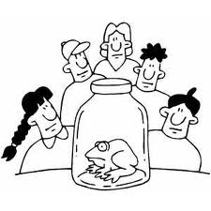
Course: Biology 11 – Semester 1 (2011) Name: _____________________
School: North Delta Secondary
School Number: 604-596-7471 Date: _____________________
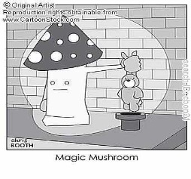
Teacher: Ms. K. Sidhu
Room Number: 2311
Textbook: BIOLOGY (Miller & Levine, 3rd Edition)

Course Website: _____________________________________________
Welcome to Biology 11!
Life. Where did living things come from? What is life? Are viruses alive? Are we anything like an earthworm or bacteria? These are a few of the intriguing and thought-provoking questions that we will answer in this course. Through indoor and outdoor group activities, dissections, and independent study, we will discover many topics that will open your mind to the big picture of LIFE and help you achieve a greater understanding of what Biology is.
Course Outline:
- Introduction Ch. 1-7  - Microscope  - Scientific Method  - Cells and DNA  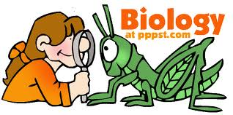  - Classification | E. Animal Biology  1.Invertebrates  a) Porifera Ch. 26  b) Cnideria Ch. 26  c) Platyhelminthes Ch. 26  d) Nematoda Ch. 26  e) Mollusca Ch. 27  f) Annelida Ch. 27  g) Echinodermata Ch. 29  h) Arthropoda Ch. 28
- Microbiology Ch. 17  - Viruses  - Kingdom Monera  - Kingdom Protista | 2. Vertebrates  a) Chordata Ch. 31-36
- Mycology Ch. 19  - Kingdom Fungi | F. Adaptation and Evolution Ch. 13 & 14
- Plant Biology  - Algae Ch. 20  - Mosses and Ferns Ch. 21  - Gymnosperms Ch. 22 & 25  - Angiosperms Ch. 22 & 25 | G. Ecology  1. The Biosphere Ch. 47  2. Populations and Communities Ch. 48
 | H. Genetics (If time remains) Ch. 9-12
Materials:
Paper, Pens, Pencils, Binder | Scientific Calculator (No Graphing Calculators)
Pencil Crayons and Project Supplies | Appropriate Clothing and Shoes for Labs
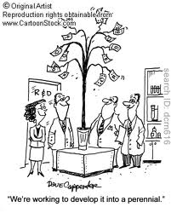
Field Trips:
Field Trip plans and fees will be discussed in the future once dates are determined.

Evaluation:
HW/Labs/Projects/Assignments: 20% Tests and Quizzes: 50%
Final Exam: 30%
The above may change based upon teacher discretion.
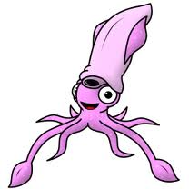
Classroom Policies:
1. Never speak while the teacher is speaking.
2. Always raise your hand to speak or to leave your seat, and wait for a response before speaking.
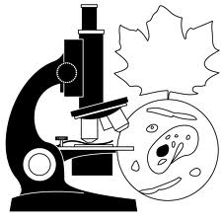
3. Respect your fellow classmates, the teacher, and the classroom. The class is a whole unit, and individuals negatively impacting the class will be dealt with appropriately.
4. No eating, sleeping or personal grooming is permitted in class.
Lates:
- Students will be kept in after class. The dice will decide for how long.
Washroom Breaks:
- Two washroom breaks are allowed per student per week. This may change based on teacher discretion.
Absences:
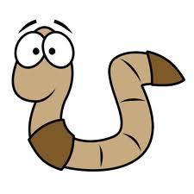
- Students are expected to collect all missed work (notes, assignments, etc.) on their own. Absences must be excused by a parent calling the school; notes will not suffice. Absences on the day of a test will only be excused for medical reasons and your parent/guardian will need to call me directly.
  - School Number: 604-596-7471 Extension: _________
Make-up work:
Students have 1 day to make up the work for each day absent, not including the day of return, unless the principal approves an extension due to unusual circumstances. Previously assigned work is due on the day the student returns to school.
Projects and Labs:
Please work cooperatively with your group members and classmates. Participate and do your share of the work. During labs, show respect for living things and specimens. Pertain to science lab safety rules at all times! Unsafe and horseplay will result in the student no longer participating in the present and future activities.
Test and quiz make-ups:
Test and quiz make-ups will only occur if the students has been excused for their absence. Students will take announced tests on first day of return to school. Student will be allowed 2-days to prepare for tests assigned during the absence.
- Most labs cannot be recreated so alternate assignments with similar or same objectives will be given for make-up work.
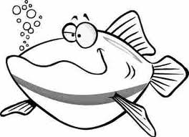
Academic Honesty Plan:
Cheating and copying of another person’s work will result in disciplinary action, and any credit for the assignment, test, or quiz will be taken away.
Tips for Success:
Be responsible for your own work and education. Not everything we do will always be hands-on or interesting, but everyone needs to achieve the patience and study skills to work productively in such situations. If you do not understand something, do something about it. Avoiding things will just make them into bigger problems, and you will eventually need to find a solution.

Please sign and have a parent sign below to acknowledge that you are aware of and accept the course outline, evaluation guide and expectations.
Student Name (print clearly) | Parent Signature
Student Signature | Study Buddy Name

