Name: Block:
Date: Science 8

10.3 – Drainage Basins, Groundwater & Glaciers

Drainage Basins
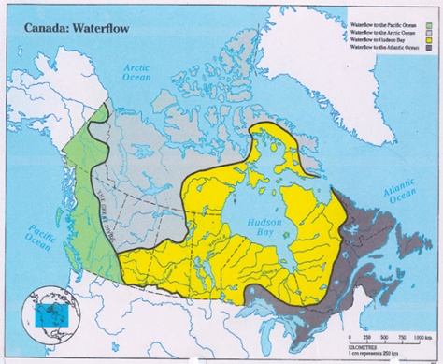
- Drainage basin =
  - E.g., in Canada, we could ask, “What is the drainage basin for the ___________________________ or the ________________________________?”
- Divide =
  - E.g., in Canada, the ____________________________ are the divide between the Pacific and Atlantic Ocean drainage basins (aka the _______________________________________)

Ground Water
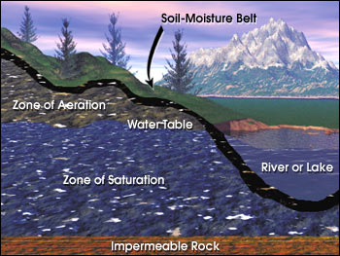
- Groundwater =
- Aquifer =

- Humans build ______________ to access water in aquifers

Glaciers
- Glacier =
  - Created when piles and piles of snow are c_____________________ to become ice
  - _____________ of the world’s fresh water is trapped in glaciers
- Two Types
  - Alpine glacier =
  - Continental glacier =
- Glaciers move d______________________ until:
- The t______________________ is warm enough to m___________ the ice (________________ elevations)
- They reach w________________ and break off to form i_____________________

