Name: Block:
Date: Science 8

10.3 – Run-off

When it rains, water…
- a) E_______________________ makes p_________________________
- b) Soaks into the ground called g________________________
- c) Stays on the s_______________________ called r________________________
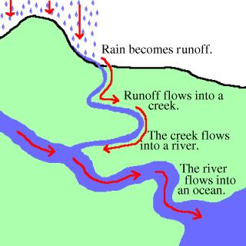

Run-Off
- Run-off =
- ________________________ pulls it downhill
stream or r___________________
pond, l_____________ or o___________________

Run-off is important to think about
- It brings ____________ and ____________ to lakes, rivers, & oceans in the water
  - M__________________
  - N__________________
  - P___________________
- These things affect p_____________ and a________________ life

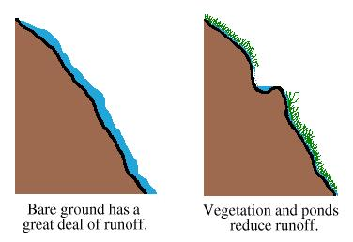
Factors that affect run-off
- Type of g_________________ material
More run-off on r____________ than s____________
- P_______________________
- Length of time
- A_______________
- S________________ of the land
Steeper land
____________ water absorbed (____________ runoff)
- V______________________ E.g., C____________________
- D________________________ (roads, cities)
C____________________ doesn’t allow water to be absorbed into the ground

Run-off Problems

- F___________________
- S____________ carried away by run-off
- P___________________
- Soil & silt churned up _________________________________

